* Start of Content Area

**Function documentation Generic Buffering  [Locate the document in its SAP Library structure](http://help.sap.com/saphelp_nwpi71/helpdata/en/f7/e4c5a8a84a11d194eb00a0c929b3c3/frameset.htm)**

**Use**

You use generic buffering to load in the buffer all the records whose generic key fields match with the accessed record of the table. The generic key is a part of the primary key of the table that is left-justified.

Example

In this example, a program reads the record highlighted in red from table *SCOUNTER*. If the table is generically buffered, all records whose generic key values (*MANDT* and *CARRID*) agree are loaded into the buffer. This is shown in the figure below.

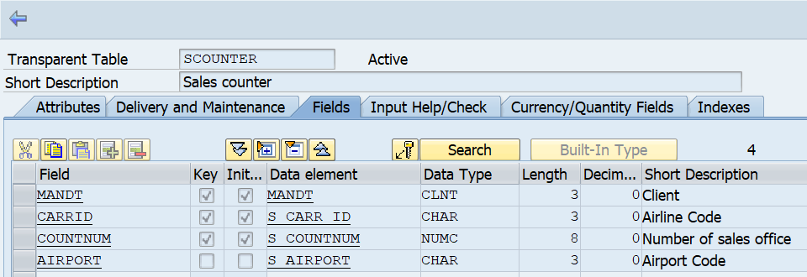

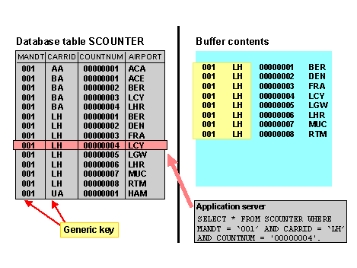

**When To Use Generic Buffering:**

When generic areas are needed.

You must generically buffer a table if only certain generic areas of the table are needed for processing.

1. For client-specific tables

Client-specific, fully-buffered tables are automatically generically buffered since it is not possible to work in all clients at the same time on an application server. The client field is the generic key.

**Features**

**Defining the Generic Key**

In generic buffering, it is crucial to define a suitable generic key.

If the generic key is too small, the buffer contains a few large areas. During access, too much data can be loaded in the buffer.

If the generic key is too large, the buffer contains too many small generic areas. These can reduce buffer performance since there is an administrative entry for every buffered generic area. It is also possible that too many accesses bypass the buffer and go directly to the database, since they do not fully define the generic key of the table. If there are only a few records in each generic area, we recommend you to fully buffer the table.

End of Content Area